**Bridesmaid Collection by Drapemoda**

A [wedding](http://drapemoda.com) outfit should be a personal choice for any woman.What she wears on her big day is a decision that she alone can make. In our country, lehengas and sarees are the most popular wedding outfit options.And while many women prefer the lehenga, some prefer to make their trousseau by picking from the most popular wedding [saree](http://drapemoda.com) collections.

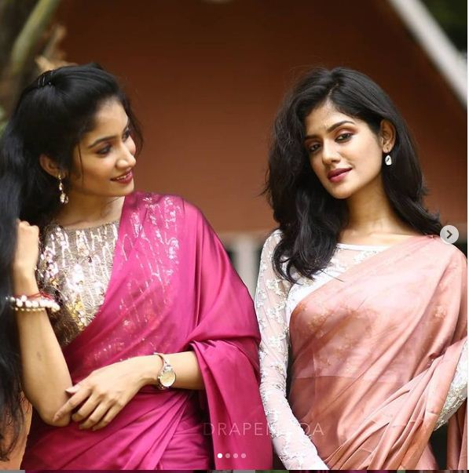

Besides silk sarees which are timeless and elegant, modern [brides](https://drapemoda.com/product-category/bridesmaid-sarees) expect glamorous saree choices, which can be worn to a party, a cocktail, or a sangeet evening.

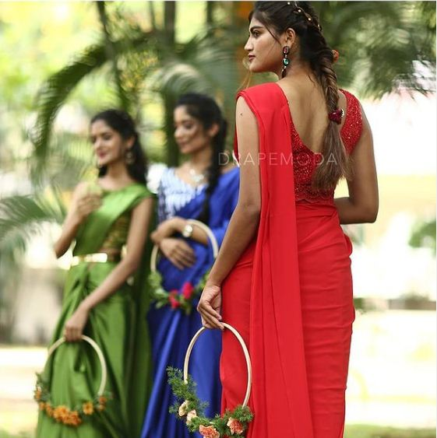

But, Why should [brides](https://drapemoda.com/product-category/bridesmaid-sarees) have all the glitter and glam? What about her best mates?

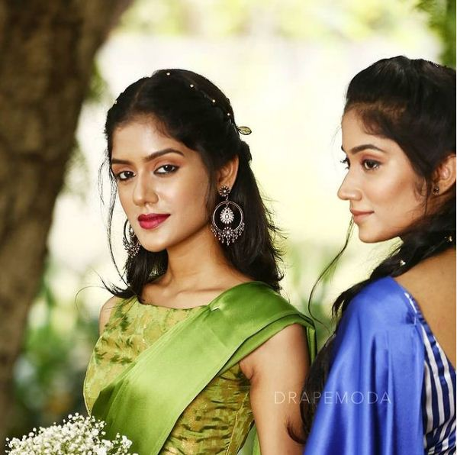

[Drapemoda](http://drapemoda.com) offers a plush solution for that dilemma. Check our new range of [Bridesmaid](https://drapemoda.com/product-category/bridesmaid-sarees) Collection. We mixed vibrant shades and sparkles to bring haute couture drapes perfectly crafted for your fashion closet.You can customize the [drapes](https://drapemoda.com/product-category/bridesmaid-sarees) to fit your style.

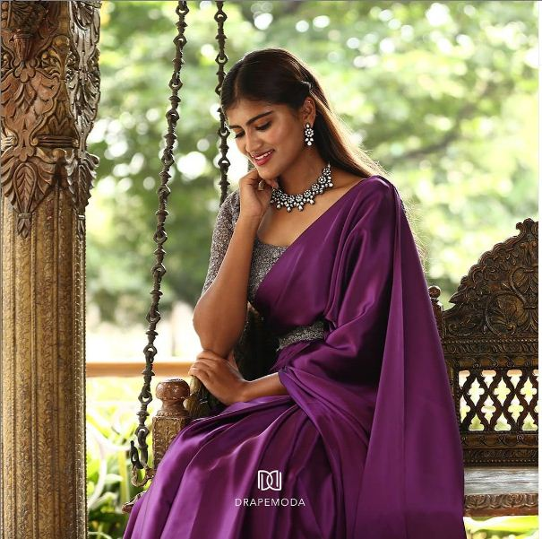

Place your order [Drapemoda](http://drapemoda.com).